# React – Question & Answers

Question:

1. What is React, and how does it differ from other front-end frameworks?
2. What are the key benefits of using React in a web application?
3. What is JSX, and how is it used in React?
4. What is the virtual DOM, and how does it improve performance in React?
5. What are React components, and how do you create and manage them?
6. How does React handle state changes and updates to the user interface?
7. What is the concept of a “single source of truth” in React, and how does it relate to state management?
8. Can you explain the difference between a controlled and uncontrolled component in React?

Answers:

1. **React** is a popular open-source JavaScript library developed by **Meta (formerly Facebook)** for building **user interfaces (UIs)**, especially for single-page applications. React allows developers to create reusable UI components that manage their own state and update efficiently when the data changes.

* **Declarative**: React enables developers to describe how the UI should look for a given application state, and it takes care of efficiently updating and rendering the components when that state changes.
* **Component-Based**: React breaks the UI into small, reusable components, making the code modular, easier to understand, and more maintainable.

**How React Differs from Other Front-End Frameworks?**

React has unique features and design principles that distinguish it from traditional front-end frameworks like Angular, Vue, and others:

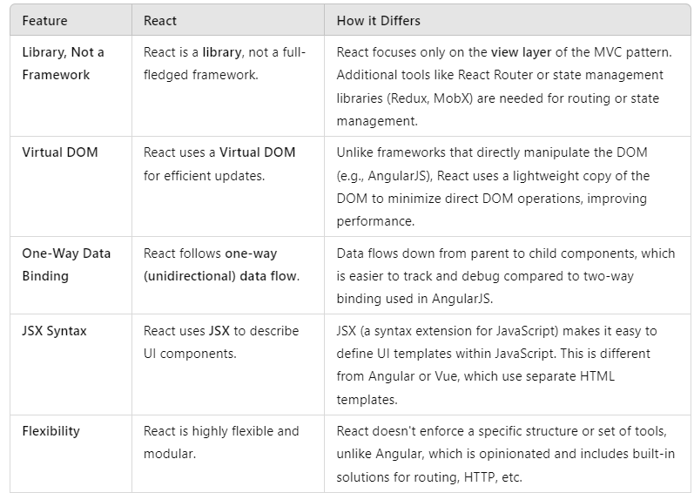

1. **Key Benefits of Using React:**  
   2.1. **Component-Based Architecture:**

* React breaks the UI into **small, reusable components**. Each component is a self-contained building block, managing its own logic and UI.

2.2. **Virtual DOM for Performance:**

* React uses a Virtual DOM, a lightweight copy of the actual DOM. When changes occur, React:
* Calculates the difference between the current and previous state of the Virtual DOM (called **reconciliation**).
* Updates only the parts of the real DOM that changed.

2.3. **Cross-Platform Development:**

* With tools like **React Native**, React code can be reused for building native mobile apps.
* This reduces development time and ensures consistent experiences across platforms.

1. **What is JSX?**  
   3.1. **JSX (JavaScript XML)** is a syntax extension for JavaScript used in React to describe what the UI should look like. It combines the power of JavaScript with an XML-like syntax, making it easier to create and visualize React components.

* JSX is **not required** to use React, but it is widely adopted because it simplifies writing components and improves code readability.
* Behind the scenes, JSX is transpiled into standard JavaScript using tools like Babel.
* Example:
* const element = <h1>Hello, World!</h1>;
* is transpiled to:
* const element = React.createElement('h1', null, 'Hello, World!');

3.2. **Embedding HTML in JavaScript**:  
JSX allows developers to write HTML-like syntax directly inside JavaScript.

* Example:
* const button = <button>Click Me</button>;

3.3. **Supports JavaScript Expressions:**

* You can embed JavaScript expressions inside JSX using curly braces {}.
* Example:
* const name = "Alice";
* const greeting = <h1>Hello, {name}!</h1>;

3.4. **Why Use JSX?**

* **Improves Readability**: Combines HTML-like syntax with JavaScript, making it easier to visualize the structure of components.
* **Tighter Integration**: Directly integrates JavaScript logic with the UI.
* **React-Specific Optimizations**: JSX is optimized for React, making the development process smoother and more efficient.

1. The **Virtual DOM (Document Object Model)** is a lightweight, in-memory representation of the real DOM. It is an abstraction that React uses to optimize updates to the actual DOM, which is often slow to manipulate directly.

* **Real DOM**: The traditional browser DOM that represents the UI elements and structure on a web page.
* **Virtual DOM**: A JavaScript object that mirrors the structure of the real DOM, enabling React to track changes efficiently.
* **How Does the Virtual DOM Work?**

4.1.Initial Rendering:

* When a React application is rendered for the first time, React creates a virtual representation of the DOM (the Virtual DOM).

4.2. Updating the Virtual DOM:

* When the state or props of a React component change, React updates the Virtual DOM to reflect the changes.
* React creates a **new Virtual DOM** for the updated state while keeping the old Virtual DOM for comparison.

4.3. Updating the Real DOM:

* React applies the calculated changes (patch) to the real DOM in an optimized way, ensuring only the necessary parts of the UI are updated.